**3D Mobile Simulation Application for Learning Seasonal Beehive Management**

A Special Problem Presented to the Faculty  
of the Institute of Computer Science  
University of the Philippines Los Baños

In Partial Fulfillment of the Requirements for the Degree of

Bachelor of Science in Computer Science

**Albert Dominic Crisostomo**

**May 2019**

The Faculty of the Institute of Computer Science

University of the Philippines Los Baños

Accepts this Special Problem Titled

**3D Mobile Simulation Application for Learning Seasonal Beehive Management**

Submitted by:

**Albert Dominic Crisostomo**

In Partial Fulfillment of the Requirements for the Degree of

Bachelor of Science in Computer Science

**PROF. ARIAN J. JACILDO**

Adviser

Date Signed

**PROF. JAIME M. SAMANIEGO**

Director

Institute of Computer Science

University of the Philippines Los Baños

Date Signed

**ACKNOWLEDGEMENT**

This research would not have been possible if it were not for my family and friends who have endlessly given their love, support, and guidance. I would like to extend my deepest gratitude to them:

To my adviser, **Prof. Arian J. Jacildo**, for sharing his knowledge about inside and outside the college life and for being exceedingly patient throughout my research and development.

To my parents, **Erick Tisalona** and **Maricris Crisostomo**, for always believing in my capabilities, guiding me towards the good path in life, and encouraging me whenever I start to doubt myself. I love you both and you truly deserve to be given back tenfold.

To my dearest friends, **Abigail Fernandez** and **Aaron Louie Lagazon**, for all the fun memories, fights and disagreements, the things we share about ourselves, and the love and friendship you have given me. I love you both and I will always cherish this.

To my organizations, **Alliance of Computer Science Students – UPLB** and **UP Sandiwa Samahang Bulakenyo**, for opening my mind on other aspects of life and teaching me lessons that I will always live up to, and for all the barkada moments we have shared.

To our soon-to-be organization, **UPLB Duckpin Bowling Club**, for rekindling my passion for the sport of bowling and all the games we have played. I hope that one day the campus recognizes our small group of bowlers.

To my highschool friends, batchmates, and teachers in **Academia De San Gabriel Archangel**, for all the lessons that helped me shape my character and morality.

And to everyone whom I have made friends with during my college life, for making my roller coaster experience in Elbi more bearable and memorable.

**TABLE OF CONTENTS**

ABSTRACT ii

INTRODUCTION 1

A. Background of the Study 1

B. Statement of the Problem 1

C. Significance of the Study 2

D. Objectives of the Study 3

RELATED WORKS 4

THEORETICAL FRAMEWORK 5

A. 3D Simulation 5

B. Beehive Management 5

C. Mobile Games 6

METHODOLOGY 7

A. Elements 7

B. Process Flows 8

C. User Interface 9

D. Implementation 15

RESULTS AND DISCUSSION 20

A. Elements 20

B. User Interface 22

C. Proper Seasonal Beehive Management Simulation 26

D. Improper Seasonal Beehive Management Simulation 27

CONCLUSION 28

RECOMMENDATIONS 29

REFERENCES 30

# ABSTRACT

The UPLB Bee Program offers the Intensive Beekeeping Course in which beekeeping experts teach the fundamentals of honey bee rearing, beehive management, and efficient production of honey. The objectives of this study were to provide another way to teach the fundamentals and explore mobile technologies by developing a mobile simulation application. A working mobile simulation application was developed, and was successful in rendering 3D models of beehive elements. Automatic beekeeping simulation was also developed along with the manual beekeeping. A quiz mode was developed to facilitate quizzes about frame types for users. It has simulated both proper and improper seasonal beehive management, and provided interactive quiz sets for users.   
   
Keywords: Beehive Management, Simulation, 3D Models, Mobile Technologies

# INTRODUCTION

## Background of the Study

The UPLB Bee Program "is a multi-disciplinary, integrated, research and extension program established in 1989 to promote, formalize and integrate all bee-related research and extension activities of UPLB" (Institute of Biological Sciences, 2013, para. 1). It employs extension programming which includes trainings, technical services, and technology promotion. Currently, its trainings include Intensive Beekeeping Course, Management of Tropical Bees, and Product Development (UPLB Bee Program, 2014). The Intensive Beekeeping Course in particular uses a combination of lectures, demonstrations, laboratory and field work, and video showing, and maintains the hands-on activities as comprising bulk of the Course (Intensive Beekeeping Training Seminar, 2015).

One of the modules of the trainings is the seasonal beehive management which currently uses a series of presentation slides for demonstration. There were attempts in the past to develop a 3D simulation of seasonal beehive management (Serrano, 2011; Clariño, 2013). All of them were developed only for desktop computers. However, this study will explore current 3D technologies in mobile devices.

## Statement of the Problem

The Intensive Beekeeping Training Course has been effective in teaching students the proper beekeeping practices by using the hands-on approach on them, and the number of enrollees has been increasing for the past years. Today, new generation of participants would require new strategies for learning, and one of the ways to perform this is to explore 3D technologies for mobile devices. Developing a 3D mobile simulation game that teaches proper seasonal beehive management, and is generally accessible to the public increases the likelihood that more prospects will be interested to enroll in the Course. This study focuses on exploring 3D technologies in mobile devices to develop a 3D mobile game based on seasonal beehive management.

## Significance of the Study

The hands-on approach has been the essential component of the Beekeeping Course. It lets the students experience firsthand the practices of a beekeeper and learn from those experiences. However, with the increasing popularity of mobile games and their usefulness for learning, developing a game for the Beekeeping Course can also be beneficial both to the students and to the Program’s administrators. The entertainment that games can give helps the players remain engaged and immersed. Moreover, they can play the game wherever and whenever they want to, as mobile games are more accessible than ever before. Combining these effects with learning new concepts, i.e. proper practices of seasonal beekeeping, the students will not only enjoy playing the game, but also learn important concepts and techniques from it. The program’s administrators can also benefit from this, as it is comparatively cheaper than hiring instructors and setting up venues for trainings.

## Objectives of the Study

The main objective of this study is to develop a 3D mobile simulation application that allows 3D simulation and interaction with seasonal beehive management. It teaches the users proper beehive practices and simulates the outcomes of proper and improper practices. Specifically, the study aims to:

1. identify the relevant seasonal beehive management elements which are food frames and boxes;

2. create 3D objects from the identified elements and provide UI to interact with these objects;

3. deploy the developed 3D mobile simulation application to Android OS; and

4. improve the accuracy and precision of the simulations and outcomes of the player’s interaction with the application.

# RELATED WORKS

Previous studies were conducted to develop a 3D simulation tool of seasonal beehive management for desktop computers (Serrano, 2011; Clariño, 2013). In 2011, Serrano simulated seasonal beehive management in a span of one (1) Beekeeping Season. Moreover, it allows users to observe the behavior of the beehive and interact with the beehive and its frame housing for bees. Lastly, the 3D simulation tool displays resulting data derived from the users’ actions and interactions with the frames inside the beehive. On the other hand, Clariño developed a desktop 3D simulation tool of the same topic, subsequent to Serrano’s study. He created features whose functionalities are similar to some of Serrano’s, but also added a new feature.

Serrano’s and Clariño’s studies were successful in laying the foundation for the development of 3D seasonal beehive management simulation. However, their simulation tools were developed only for desktop computers, which is the studies’ gap given the current trend of computer technologies.

# THEORETICAL FRAMEWORK

## 3D Simulation

Simulation is a branch of computer science that is defined as a representation of the main features of a system (Nazir, Altaf, Iqbal & Sarwar, 2011). It was first used as a military simulation in the 1960s. Since then, it has become a wide field of knowledge and is used for different purposes such as education, scientific modeling, video games, introduction to new technology, and so on (Nazir et al., 2011). The continuous advancements in computer hardware and software enabled the development of more sophisticated and interactive simulation environments. These environments are designed to allow users to experiment with different parameters and then analyze the outcomes after some interactions, giving the users the opportunity to improve their decision-making capabilities (Barbosa, 2015).

3D simulation aims to represent the functionalities of a proposed physical system, while creating visual models that appear realistic. Due to its nature, developers have more room to improve interactivity and visual aesthetics of their simulations, subsequently engaging more people to learn and observe (Santosa, Ikaruga, & Kobayashi, 2015).

## Beehive Management

Beehive management, also known as beekeeping, is the management man-made beehives in order to expand the residing bee colonies and eventually harvest honey from them (Bradbear, 2009). Bees in their natural habitats have contributed to the proliferation of various species of flowering plants and crops. Bee species that are nurtured for beekeeping purposes are also capable of doing such feat; thus, their honey gathering routine is beneficial to the natural environment, including forests (Agera, 2011). Beekeeping produces honey and beeswax, which can be made into various products. Some of those products are candles, cosmetic and skin care products, herbal medicines (propolis), and royal jelly.

## Mobile Games

Smartphones are becoming more and more ubiquitous. It began from simple tasks such as sending and receiving SMS texts from one phone to another, to more sophisticated and complex tasks such as providing access to the Internet, interact with various kinds of mobile applications, and so on. One kind of those applications is mobile games.

Generally, mobile games are consumed by end-users for entertainment. Most of the developers of these games implement the â€œfreemiumâ€ model to generate income from their consumers. This business model enacts the development of a free-to-play mobile game with in-app purchases (Heier, 2015). However, there are still some games that do not use this model, offering only a free-to-play mobile game. Some of them are “serious games,” which are games that offer not only entertainment but also some other form of incentive, in general. Specifically, mobile serious games can be those that offer not only entertainment, but also learnings from a field of knowledge (Sugimura et al., 2014).

# METHODOLOGY

Blender was used in creating the 3D models such as the wired frame and the Langstroth boxed hive, based on the specifications provided by the UPLB Bee Program (Cervancia, Fajardo, Manila-Fajardo, & Lucero, 2012). The game engine Unity3D was used in developing the simulation app. C# was the programming language used for implementing the simulation logic and other back-end functionalities.

## Elements

The elements found in the simulation are the frames, bees, and boxed hive. The frames are where bees form the honeycombs. The boxed hive is where all the frames will be placed in. The bees are the ones gathering food, feeding the brood, and creating sticky frames. The following are five types of frames:

• *Food Frame*: it contains food.

• *Open Brood Frame*: it consists of egg or larvae.

• *Sealed Brood Frame*: it is composed of pupa.

• *Sticky Frame*: it contains honeycomb.

• *Foundation Frame*: it is constructed with wax foundation for bees to build honeycomb.

## Process Flows

When a new frame is added, it is a foundation frame. In 14 days (in-app), the bees will transform it into a sticky frame. The sticky frame can transform into an open brood frame. If it becomes an open brood frame, the eggs/larvae will transform into pupa after 9 days turning the frame into a sealed brood frame. After 12 days, the pupa will fully mature into adult bees leaving the frame empty making it a sticky frame. Fig. 1 illustrates the frame cycle.

Figure 1: Flowchart of frame cycle

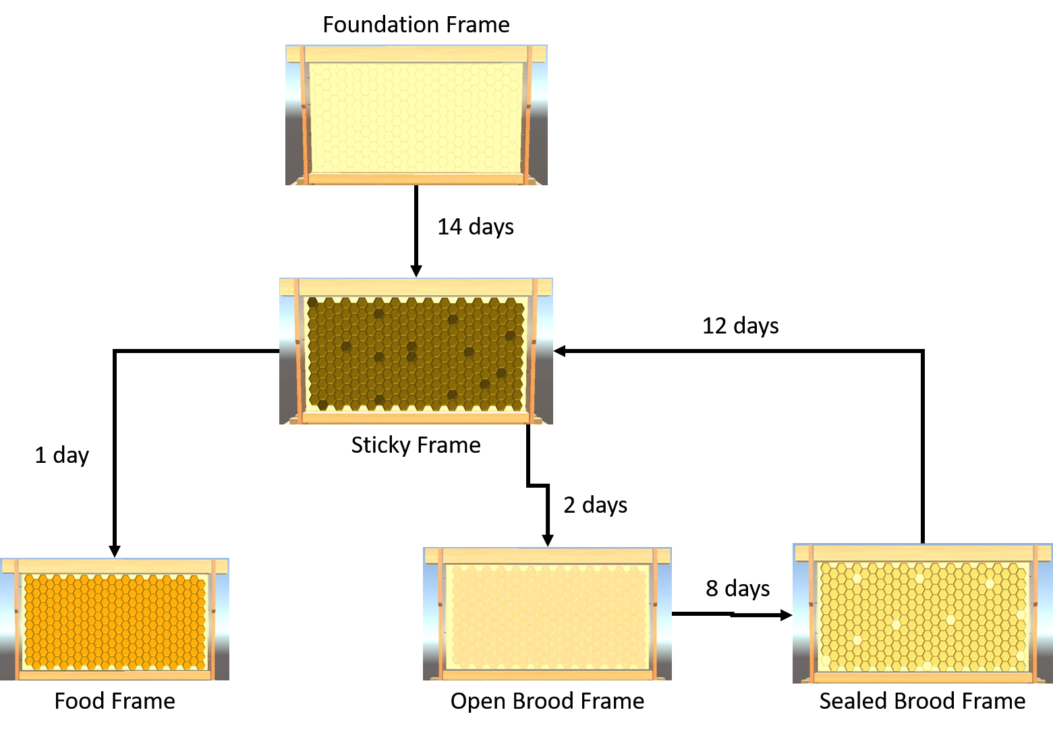

The following are the steps for Proper Seasonal Beehive Management:

1. Make a nucleus colony.

2. Place Foundation Frames to expand colony.

3. Place Food Frames to feed colony.

4. Keep Brood frames in the relative center of the hive.

5. Place new Sticky Frames in the relative center for the queen to lay eggs in.

6. If there is too little food, place Food Frame.

7. Repeat Step 2 until the colony has 10 Frames.

Below are some of the Improper Beehive Management practices, such as:

• not placing Foundation Frames;

• adding Foundation Frames too soon or too late; and

• placing Sticky Frames in unsuitable locations.

## User Interface

The mobile simulation application contains 4 scenes, i.e. the Main Menu, the Quiz, the Automatic Beekeeping, and the Manual Beekeeping as shown in Fig. 2, Fig. 3, Fig. 4, and Fig. 5. Each scene contains different UI elements, while the functionalities of some elements are shared among the scenes. Below are the UI elements developed in the mobile app:

• *Automatic Beekeeping*: It is a button that allows the user to observe automatic simulation of proper beehive management.

• *Manual Beekeeping*: It is a button that allows the user to manually interact with the beehive.

• *Quiz*: It is a button that facilitates a quiz about frame types for the user.

• *Set 1*: It is a button that loads the frames in a proper setup.

• *Set 2*: It is a button that loads the frames in an improper setup.

• *Set 3*: It is a button that loads the frames in another improper setup.

• *Reset*: It restores the current state of the Set back to its original one.

• *Score Label*: It displays the current score of the user in a current Set.

• *Raise All Frames*: It is a button that lifts all present frame above the boxed hive.

• *Lower All Frames*: It lowers all present frame above the boxed hive.

• *Move Frame to Back*: It is a button that moves currently selected frame backwards.

• *Move Frame to Front*: It moves currently selected frame to the front of the boxed hive.

• *Move Frame to Back*: It is a button that moves currently selected frame backwards.

• *Raise Frame*: It is a button that lifts the currently selected frame.

• *Lower Frame*: It is a button that lowers the currently selected frame.

• *Simulate*: It starts the automatic simulation of proper seasonal beehive management.

• *Toggle Graph*: It is a button that toggles the visibility of the Graph.

• *Graph*: It is a line graph feature that displays the total population of bees per in-app day.

• *Monitor*: It is a group of text labels which displays the current Day, Food count, Egg count, Pupa count, Worker count, and Total Population.

• *Foundation Frame*: It is a button that renders a Foundation Frame at the nearest available spot of the boxed hive.

• *Open Brood Frame*: It renders an Open Brood Frame.

• *Sealed Brood Frame*: It renders a Sealed Brood Frame at the nearest available spot of the boxed hive.

• *Sticky Frame*: It renders a Sticky Frame at the nearest available spot of the boxed hive.

• *Food Frame*: It renders a Food Frame at the nearest available spot of the boxed hive.

• *Pause/Play*: It is a button that pauses or resumes the progress of automatic beehive management.

• *Simulation Speed Button*: It is a a group of buttons that change the speed of the simulation.

• *Next Day*: It is a button that proceeds the manual simulation towards the next in-app day.

• *Exit Apis*: It is a button that exits the scene.

• *Quit*: It is a button that closes the mobile application.

Figure 2: The development of Main Menu UI

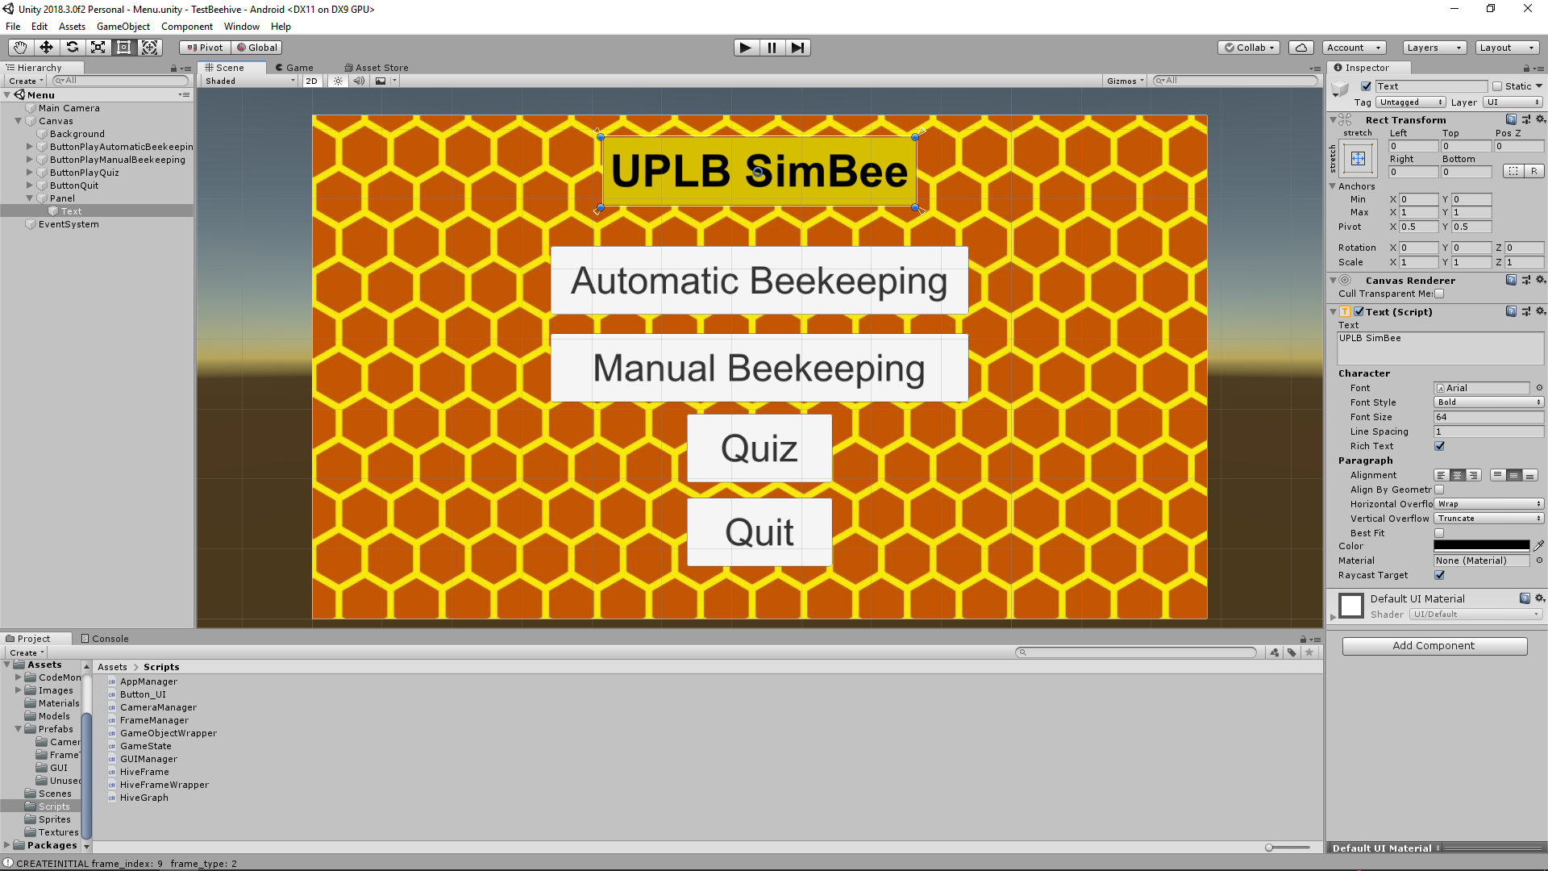

Figure 3: The development of Quiz UI

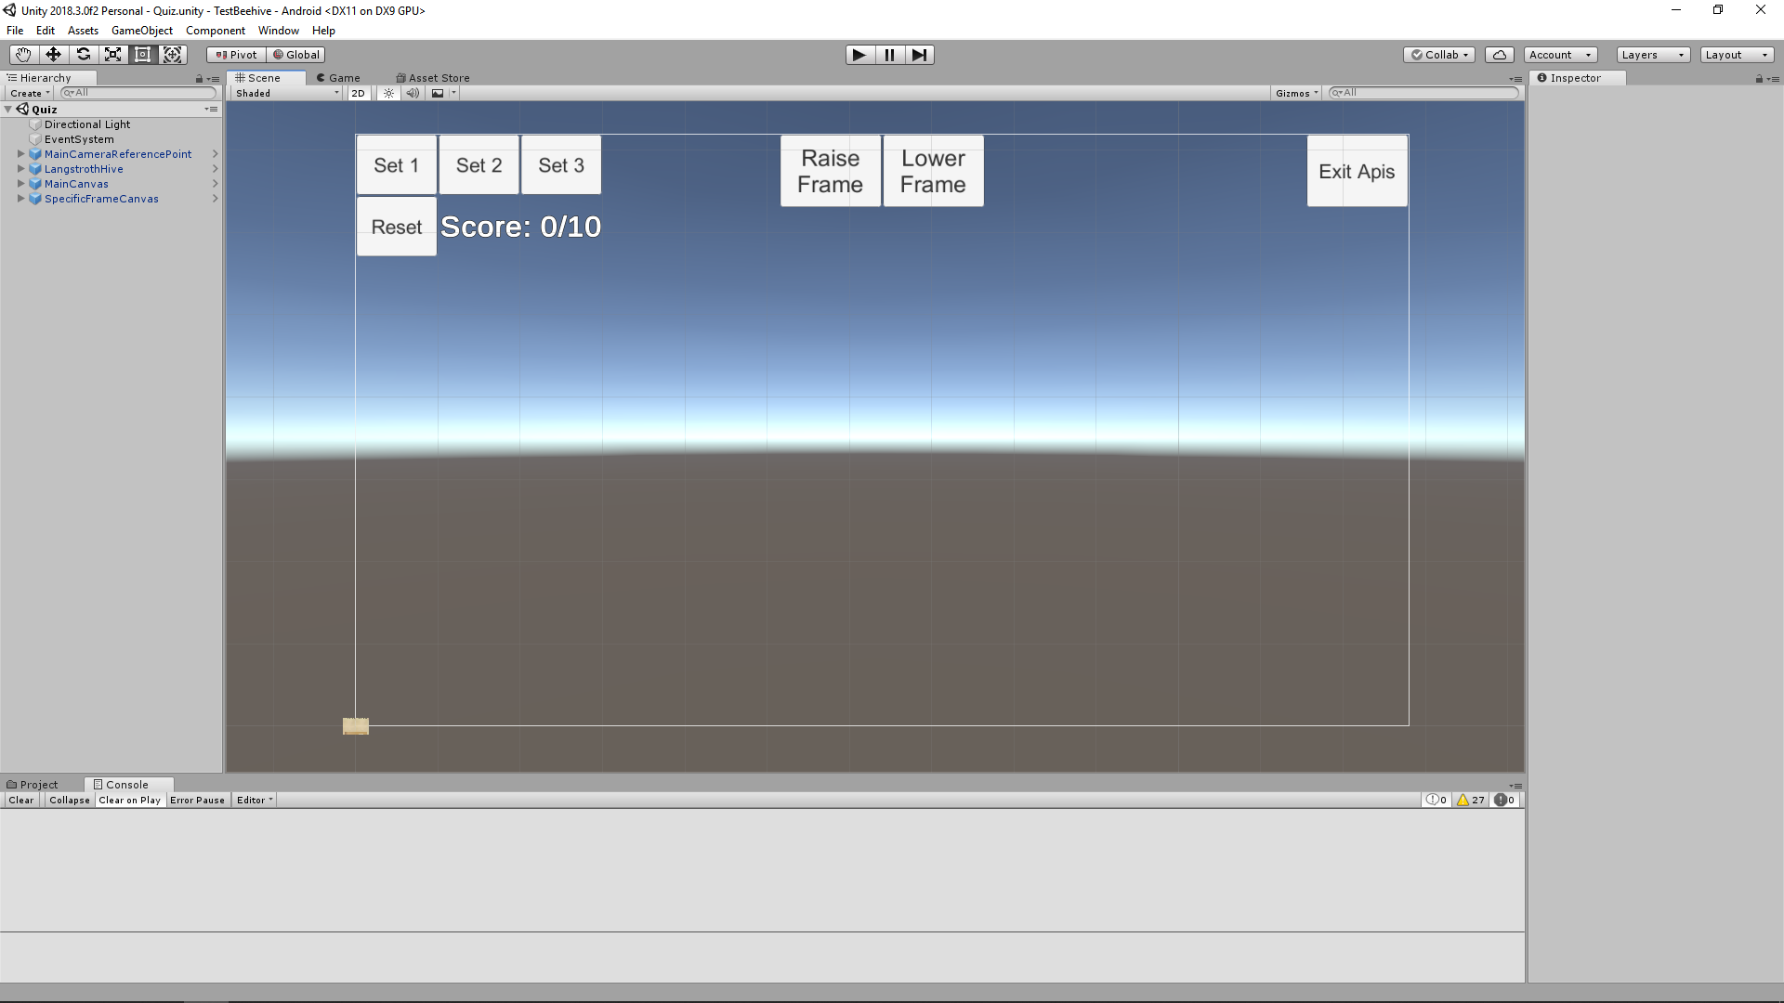

Figure 4: The development of Automatic Beekeeping UI

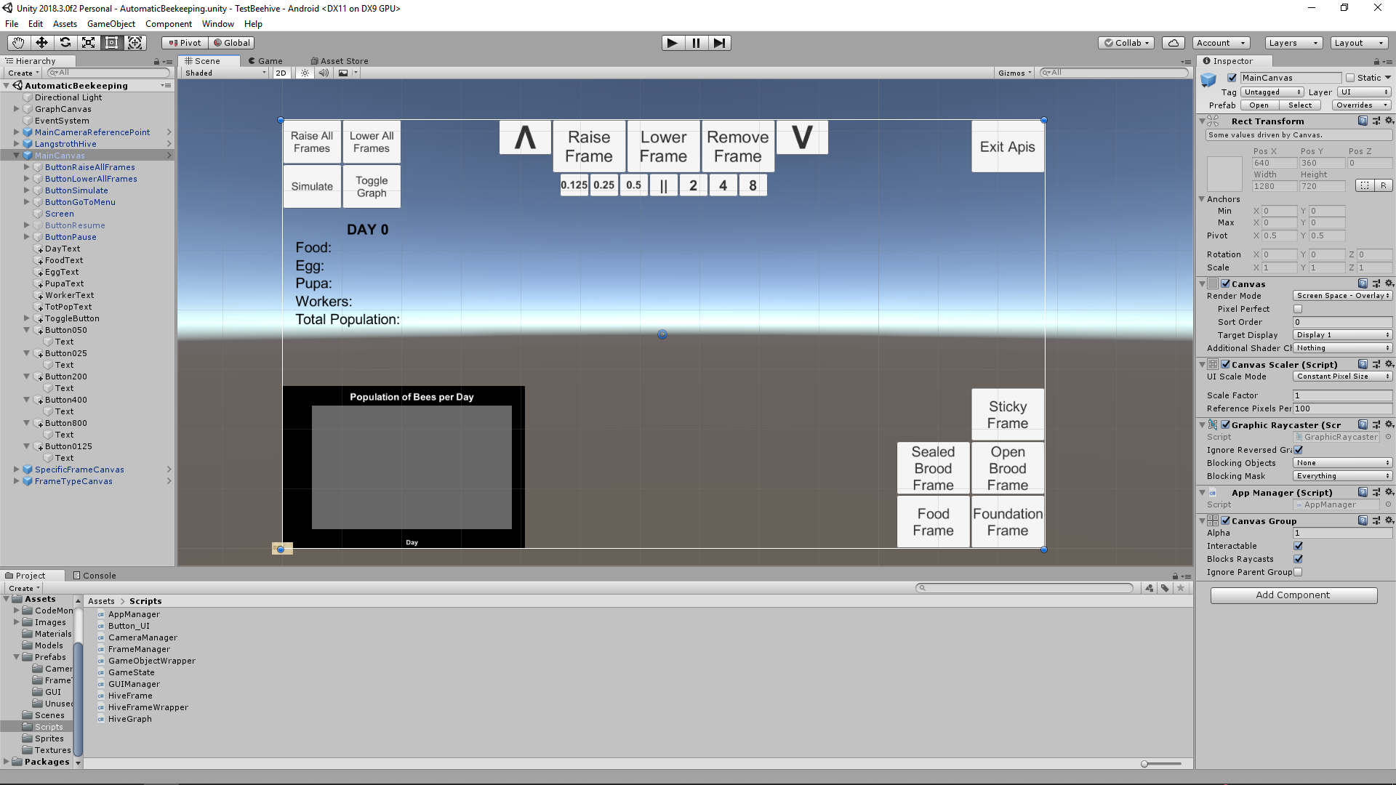

Figure 5: The development of Manual Beekeeping UI

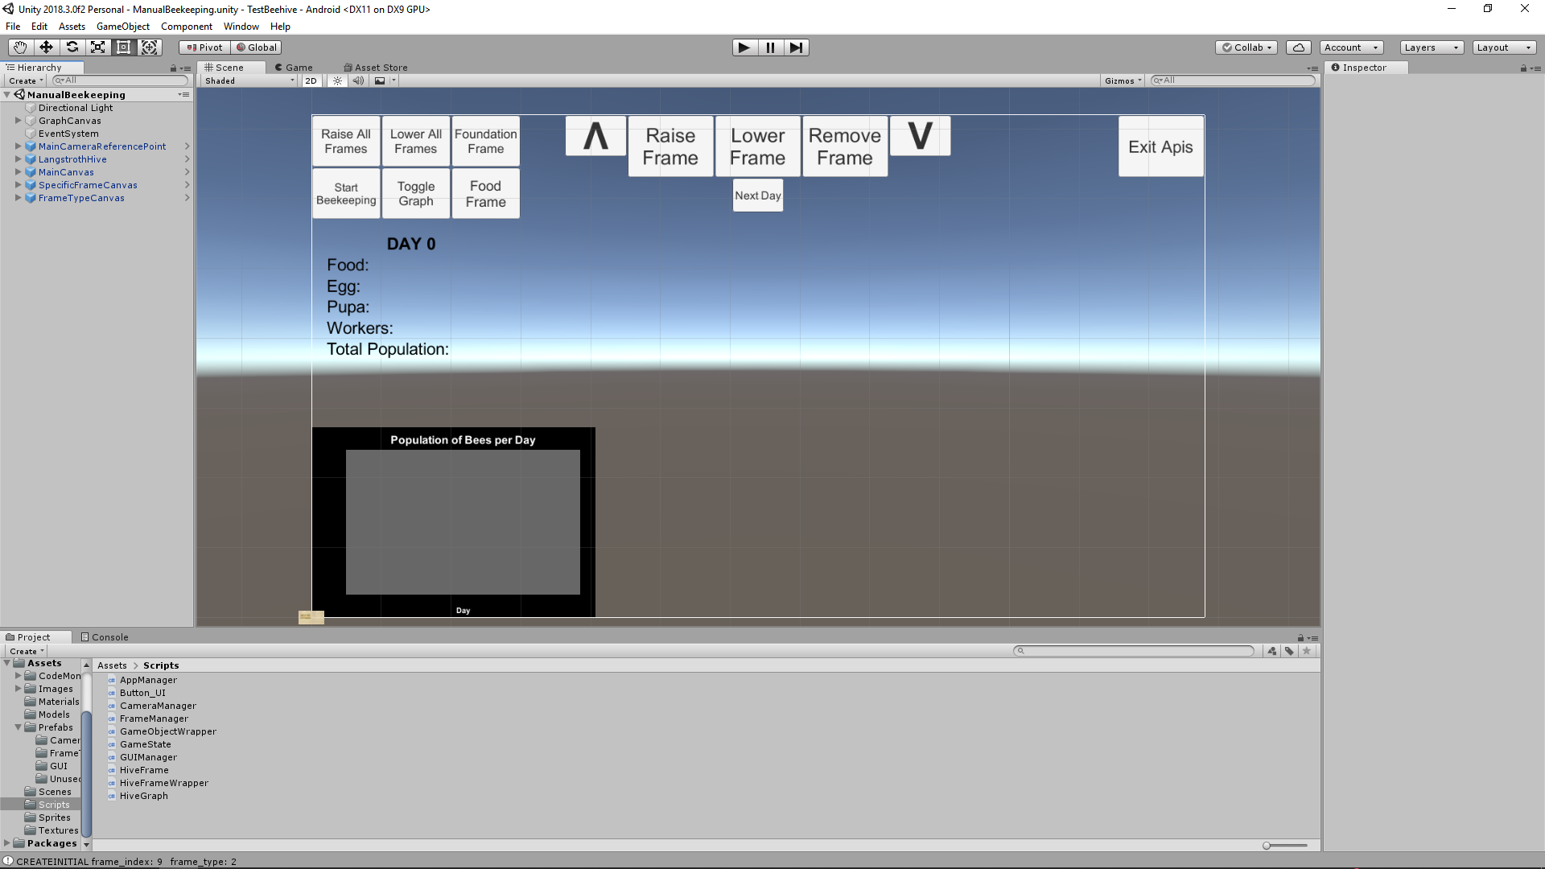

## Implementation

The boxed hive model was created from a Blender-default 3D cube model. The model’s top face was then removed. It was then cut into 4 sections to make the model creation more manageable. The model was molded and then applied with Mirroring operation. Afterwards, a texture map was created for the model. Revisions for the texture were done in MS PowerPoint 2013. Fig. 6 depicts the process of creating the boxed hive.

Figure 6: Creation process of Langstroth boxed hive model

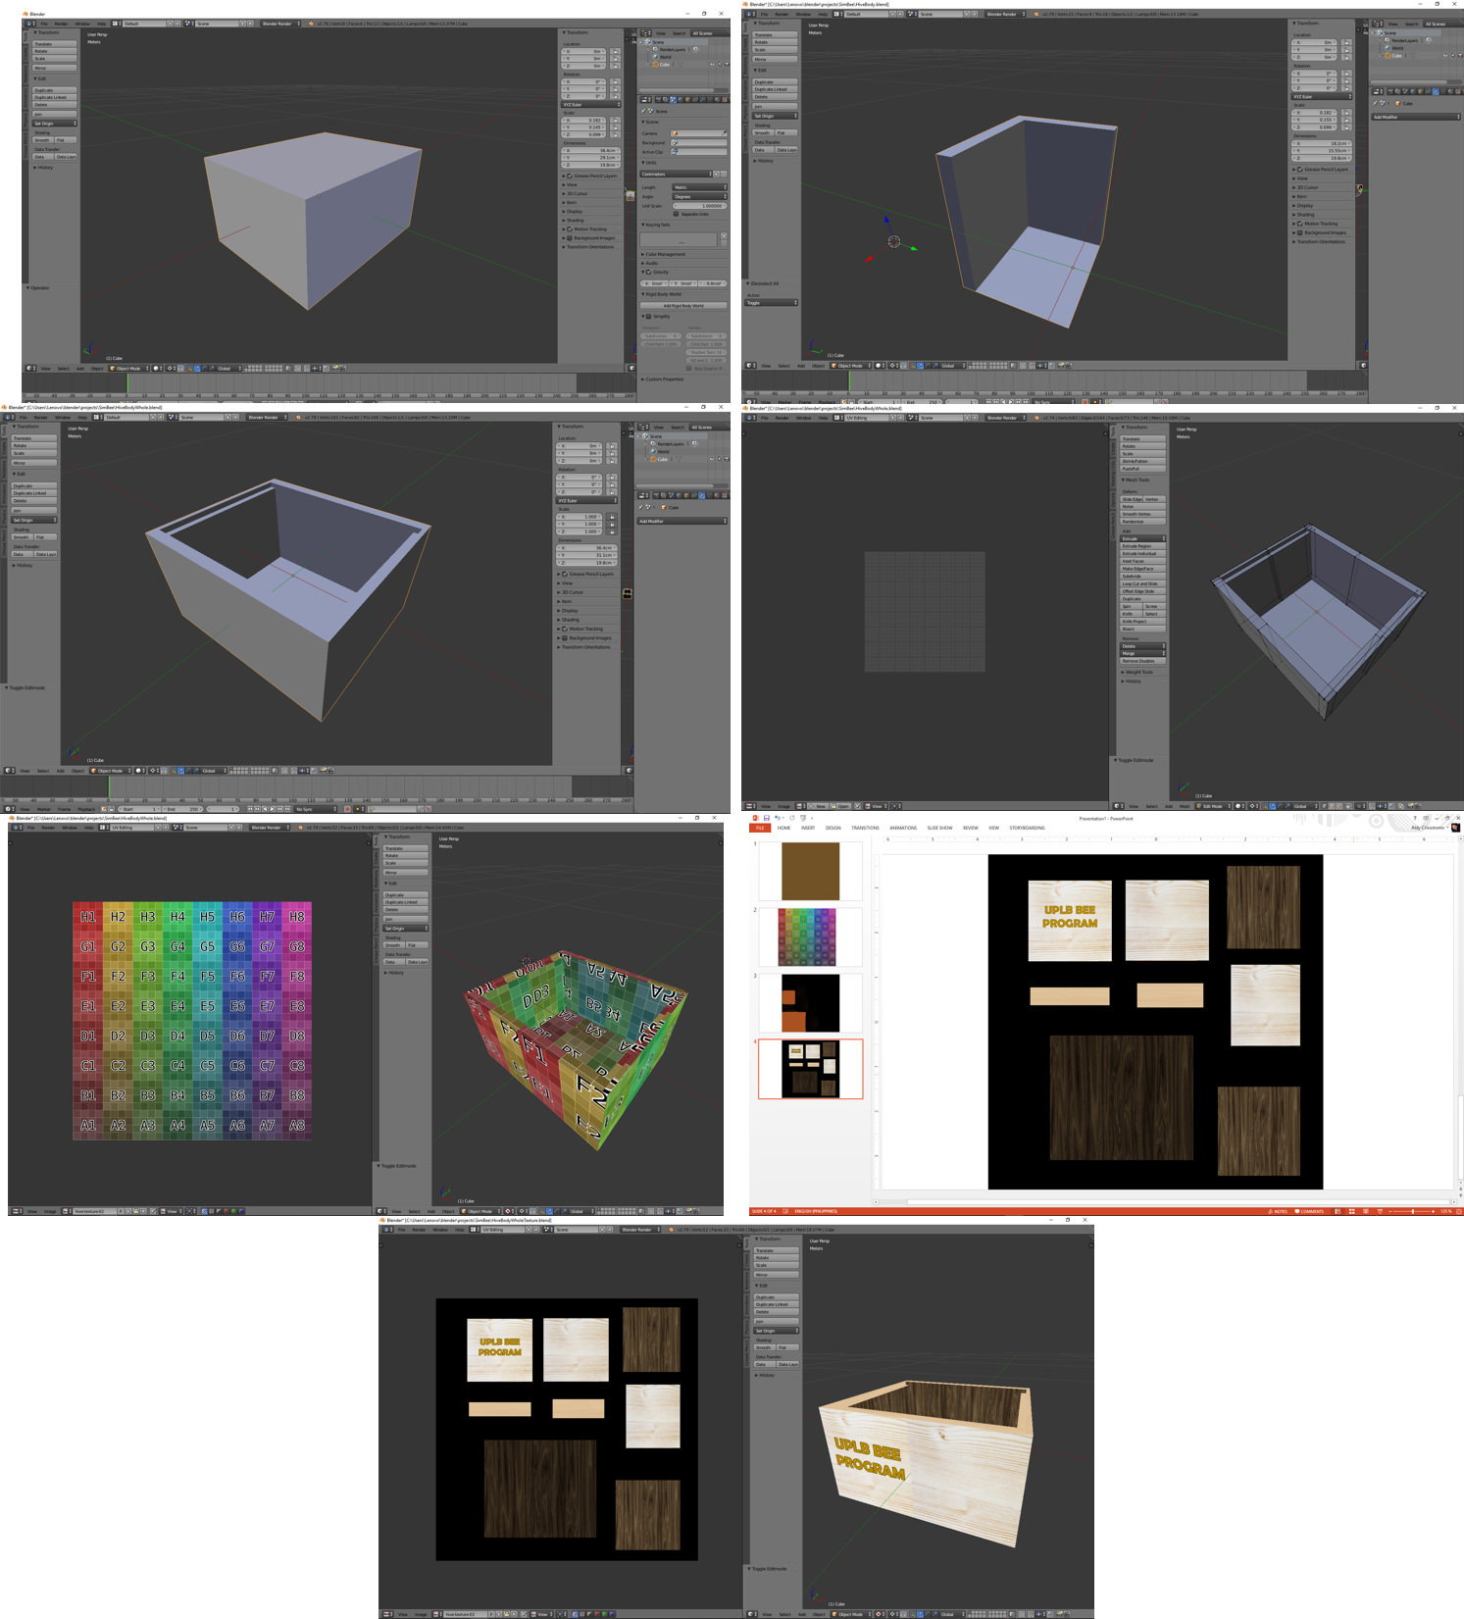

The same steps were also done for the wired frame. Fig. 7 shows the creation process for the wired Frame.

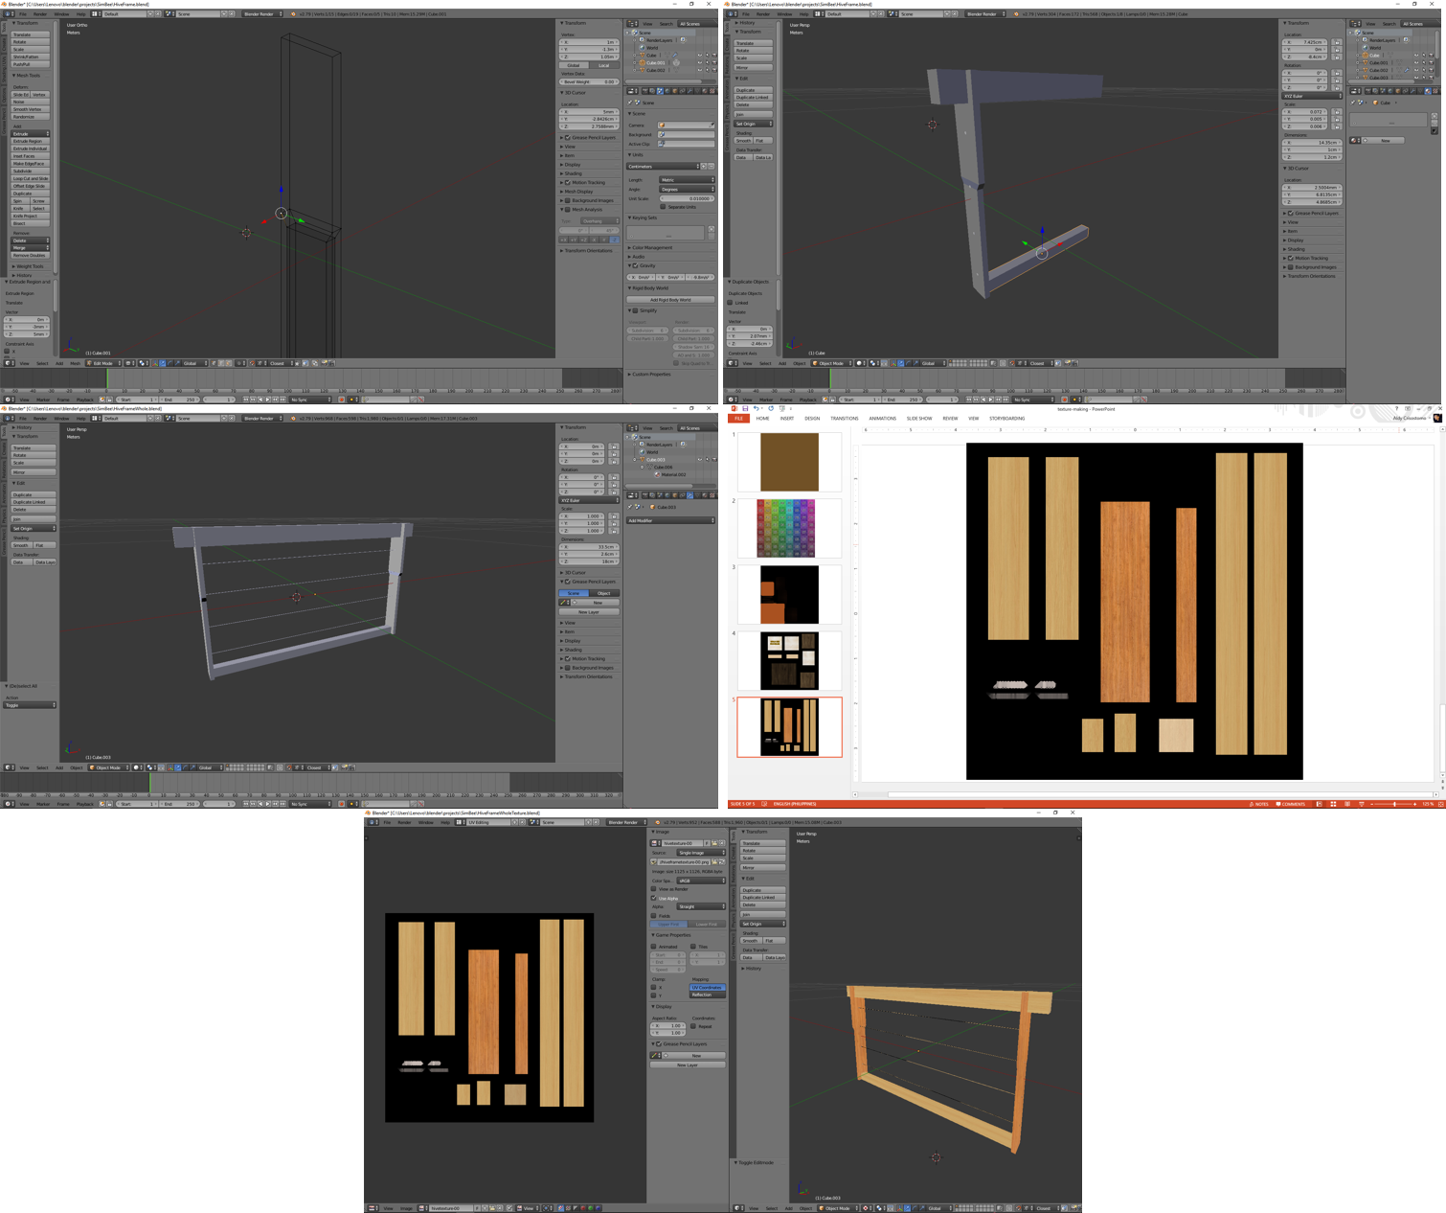

Figure 7: Creation process of wired Frame model

MS PowerPoint 2013 was used in creating the separate textures for the frame types, as seen in Fig. 8.

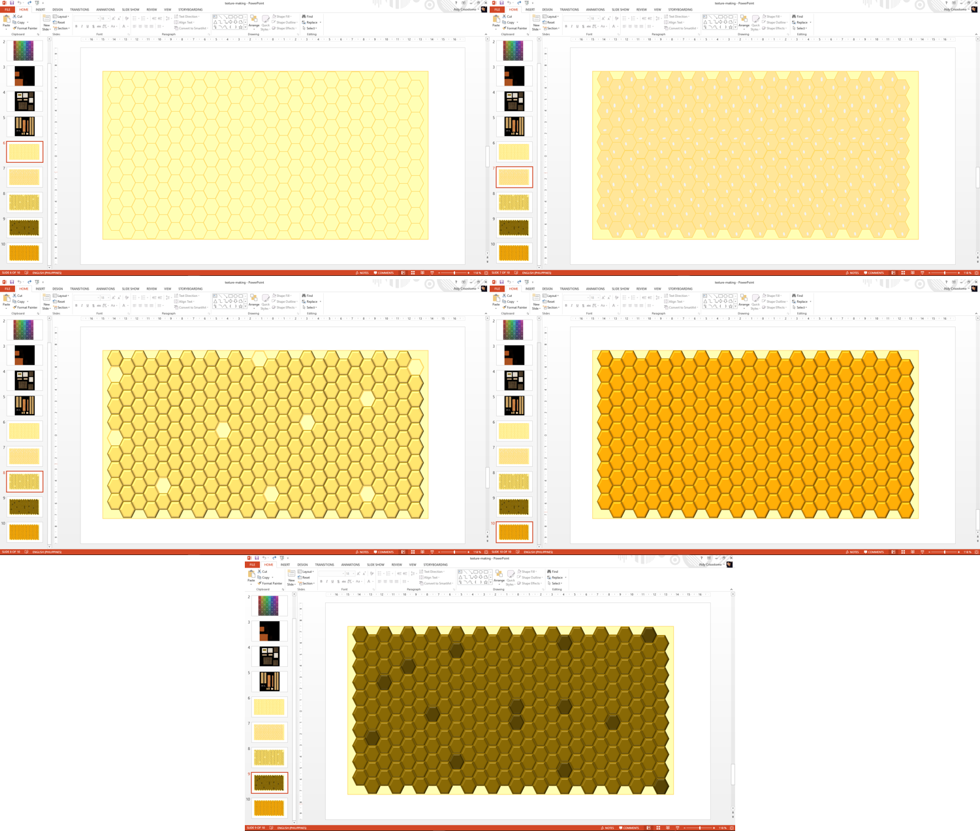

Figure 8: From left-to-right: the Foundation frame, Open Brood Frame, Sealed Brood Frame, Sticky Frame, and Food frame

The Unity game engine was used in developing the logic of the application along with the integration of the 3D models and textures. The drag-and-drop feature of the engine was utilized to design the UI elements of the simulation application. Fig. 9 shows the development process of the mobile application.

Figure 9: The development process of the mobile application

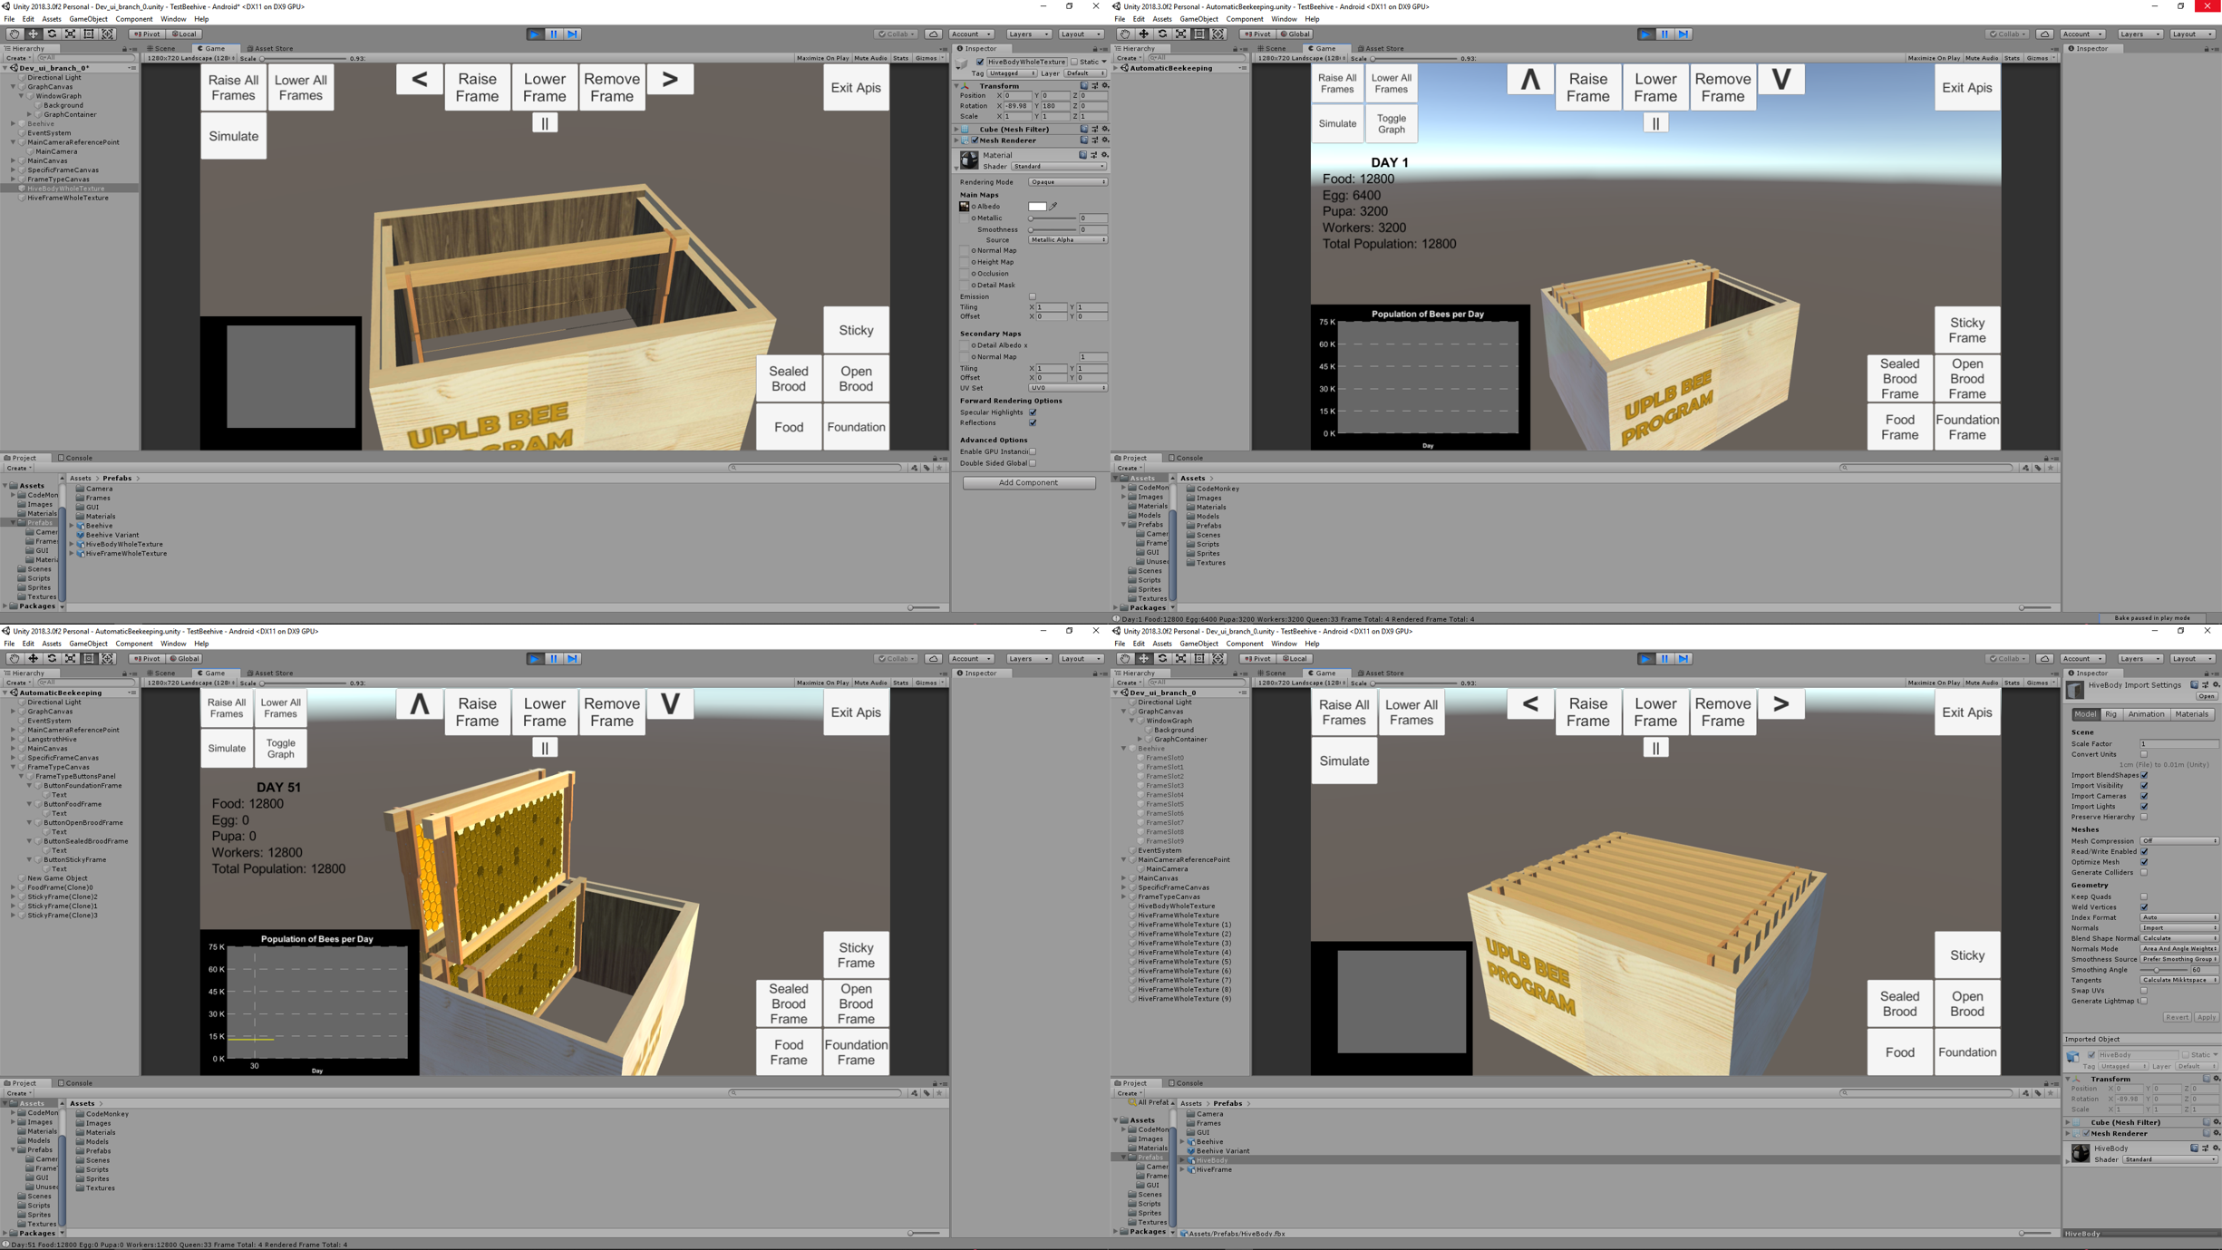

# RESULTS AND DISCUSSION

## Elements

The researcher was able to abstract and create 3D models of the equipment used in seasonal beehive management, as shown in Fig. 10 and Fig. 11.

Figure 10: 3D model of the Langstroth boxed hive, housing different frame types

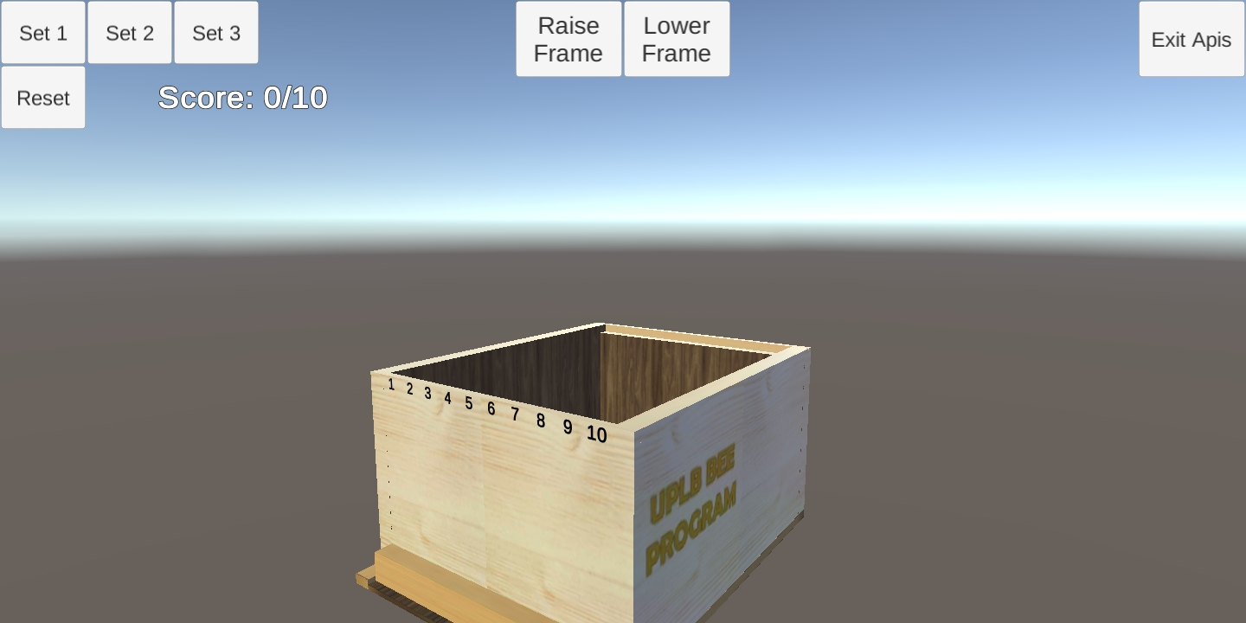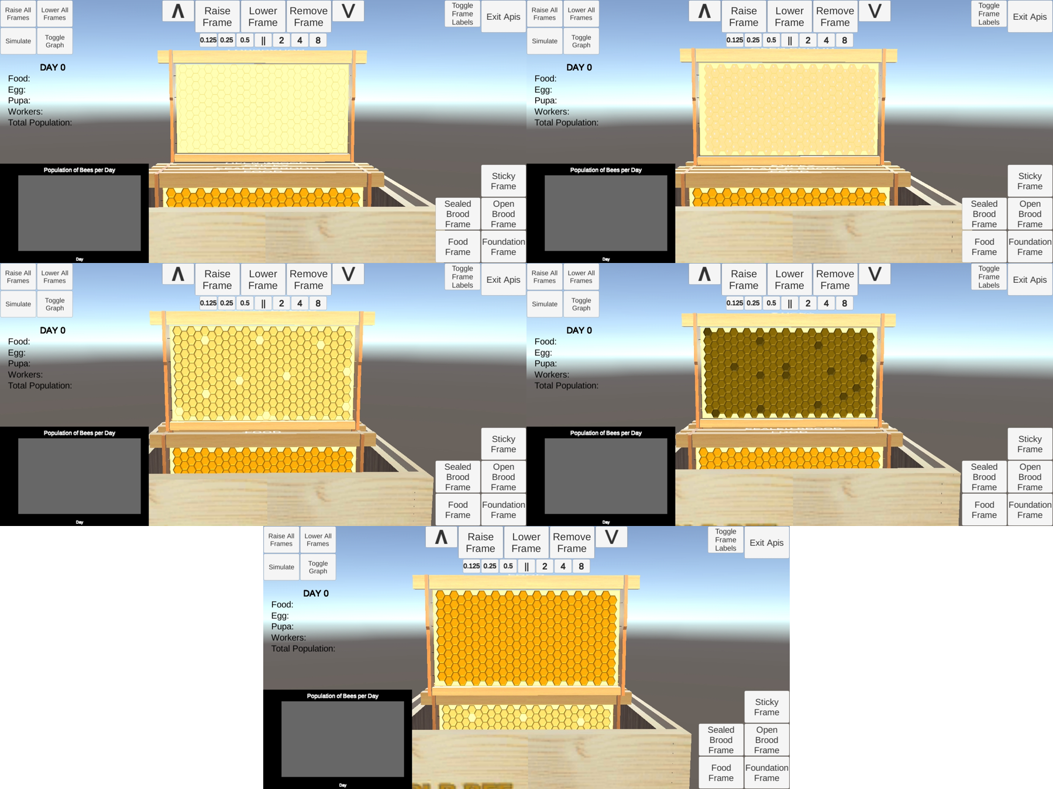

Figure 11: From left-to-right: Foundation Frame, Open Brood Frame, Sealed Brood Frame, Sticky Frame, and Food Frame

## User Interface

The researcher was also able to develop a working main menu that can lead the user to either of the three modes of interaction: Quiz, Automatic Beekeeping, and Manual Beekeeping. Fig. 12 shows the Menu. Fig. 13, Fig. 14, and Fig. 15 show the use of the Quiz mode. Fig. 16 and Fig. 17 show the Automatic and Manual Beekeeping modes.

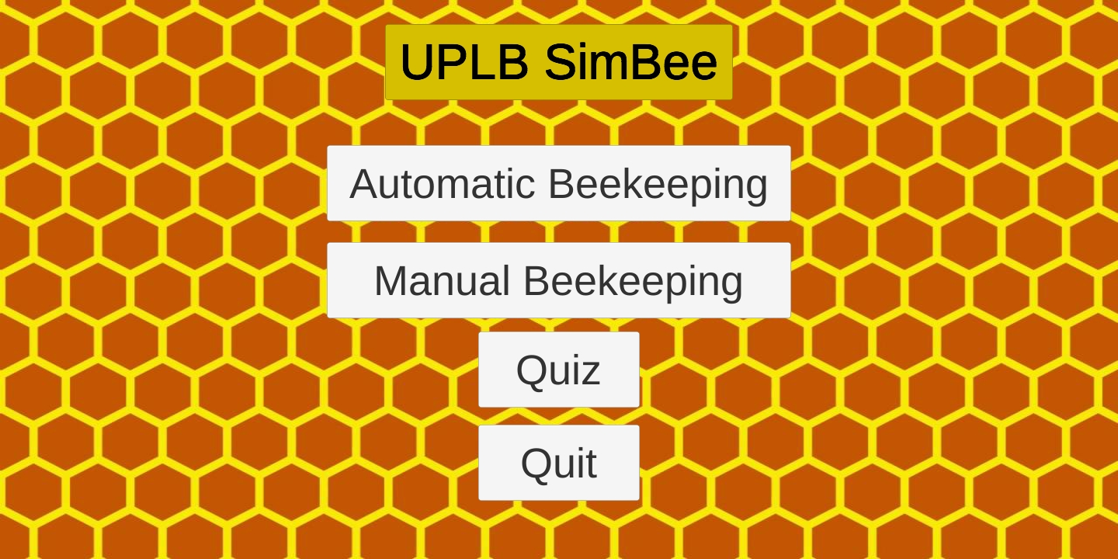

Figure 12: The main menu of the mobile application

Figure 13: A user attempting to answer a Quiz item

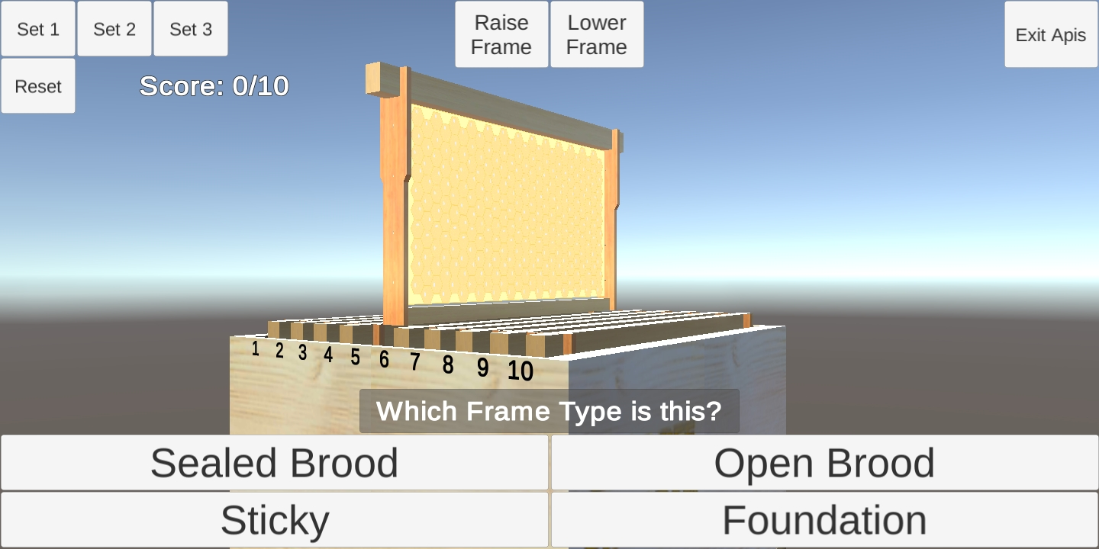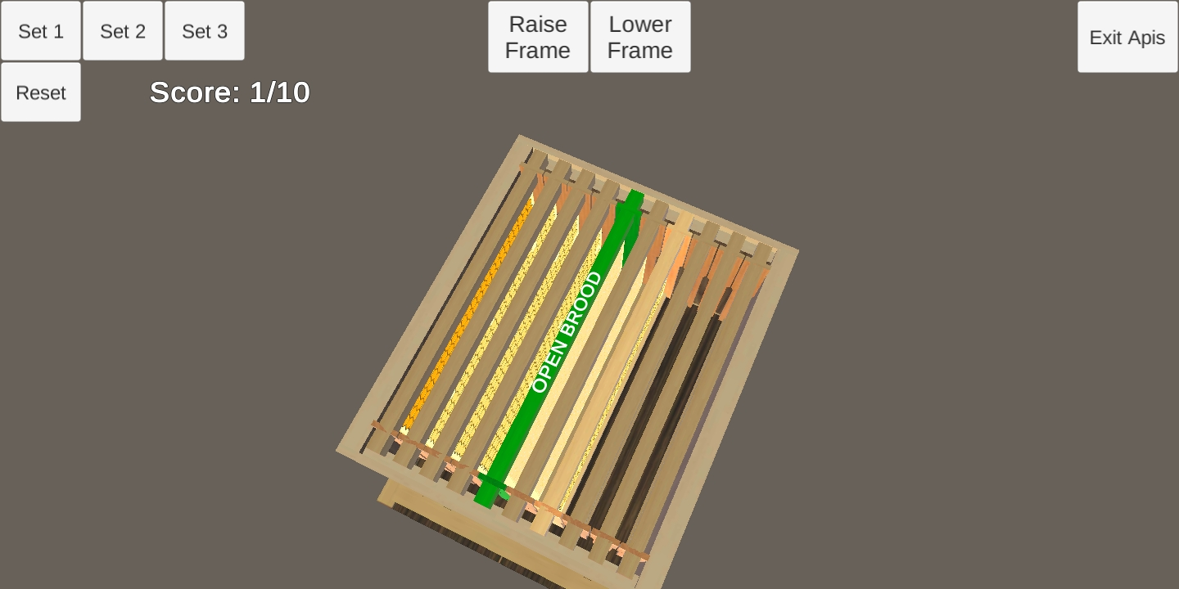

Figure 14: A green frame after giving a correct answer

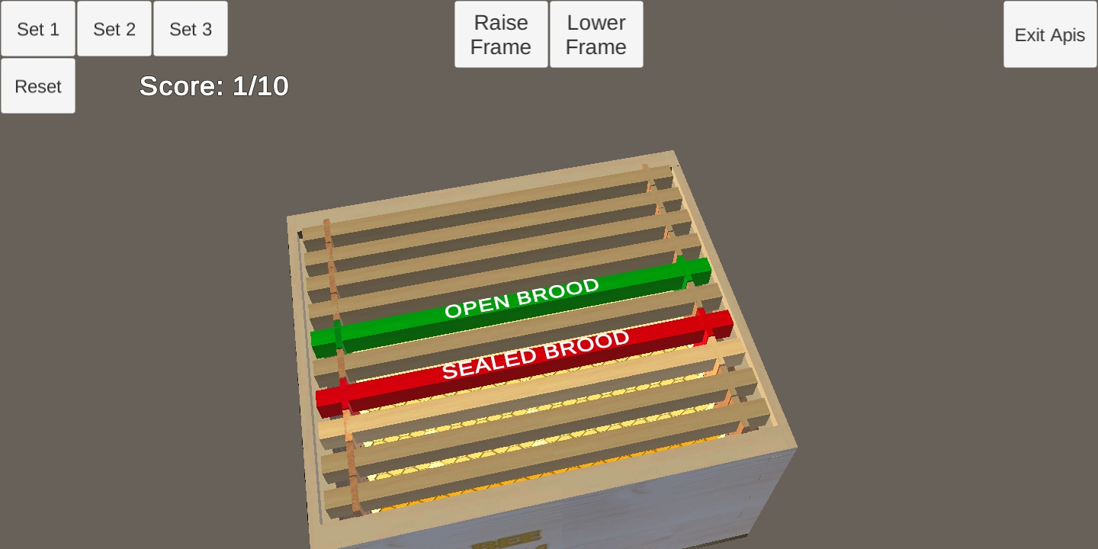

Figure 15: A red frame after giving a wrong answer

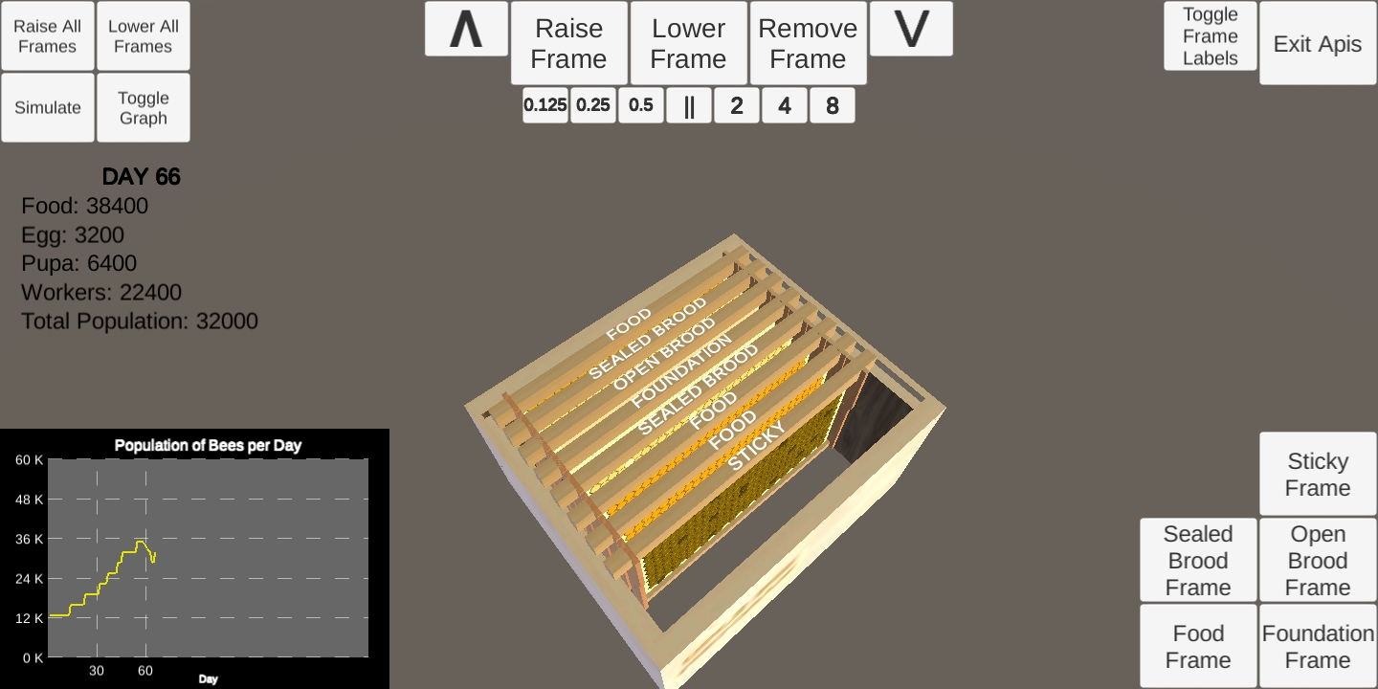

Figure 16: The Automatic Beekeeping mode

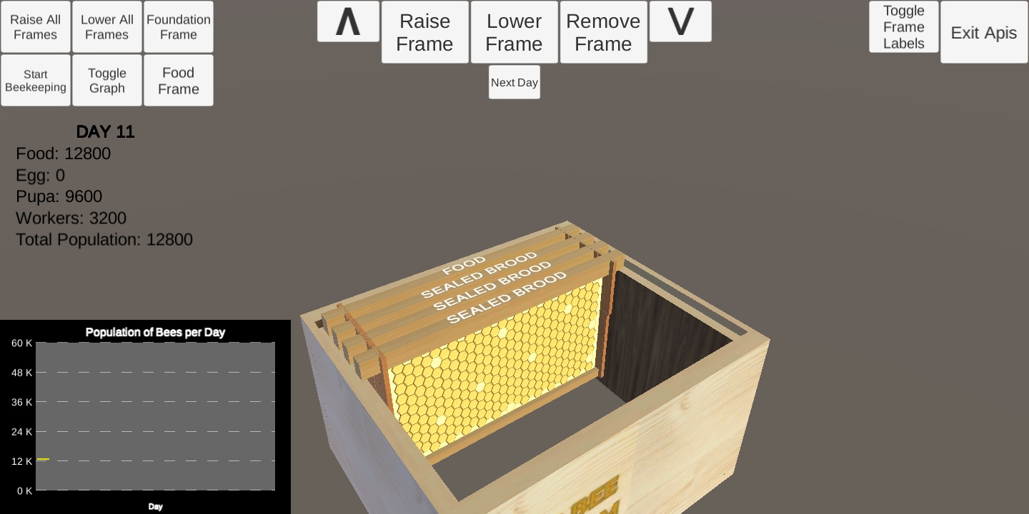

Figure 17: The Manual Beekeeping mode

## Proper Seasonal Beehive Management Simulation

The simulation model follows the proper seasonal beekeeping setup. The hive starts with a Food Frame, an Open Brood Frame, a Sealed Brood Frame and an Open Brood Frame placed in that order. The first season is July-December and prioritizes brood expansion. If there are no more frames to lay eggs in or gather food in, a foundation frame is added until there are 10 frames. New sticky frames for expanding brood is relocated to the relative center of the hive for the queen to lay eggs into. Fig. 18 shows an automatic simulation of proper seasonal beehive management. The yellow line graph shows the progression of the bee population as in-app days go on.

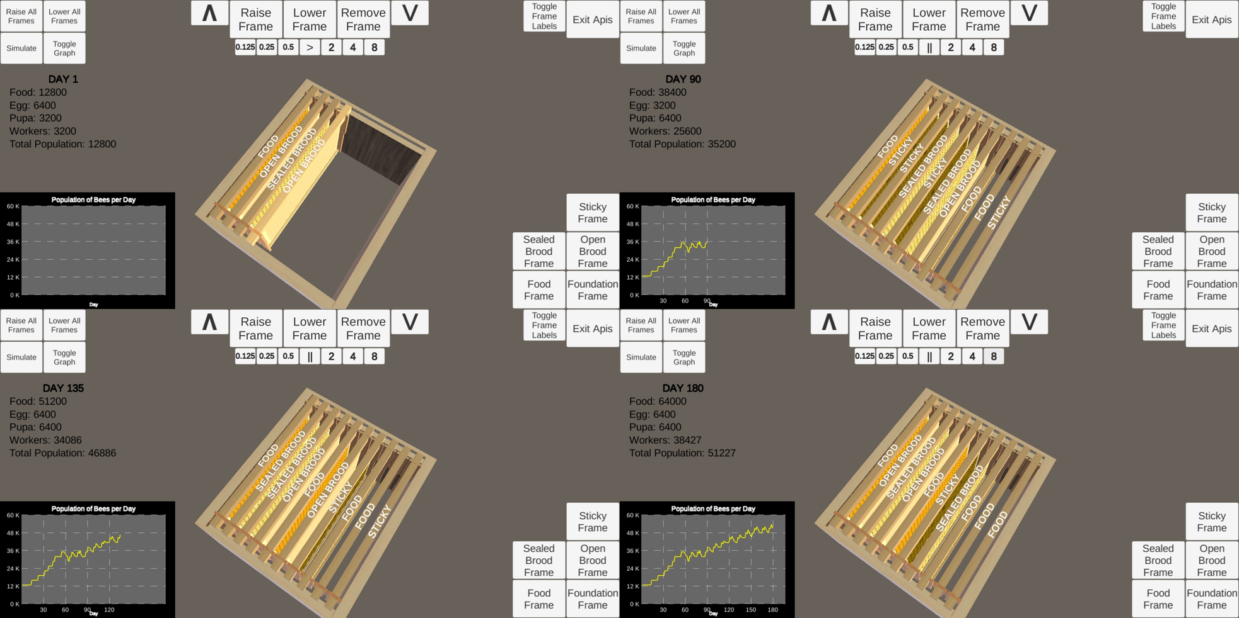

Figure 18: Image sequence depicting proper beehive management

## Improper Seasonal Beehive Management Simulation

An improper practice of beehive management was demonstrated in the application. Sticky frames were relocated in an unsuitable frame slot within the first few in-app days. The outcome was reflected in the red line graph, as shown in Fig. 19.

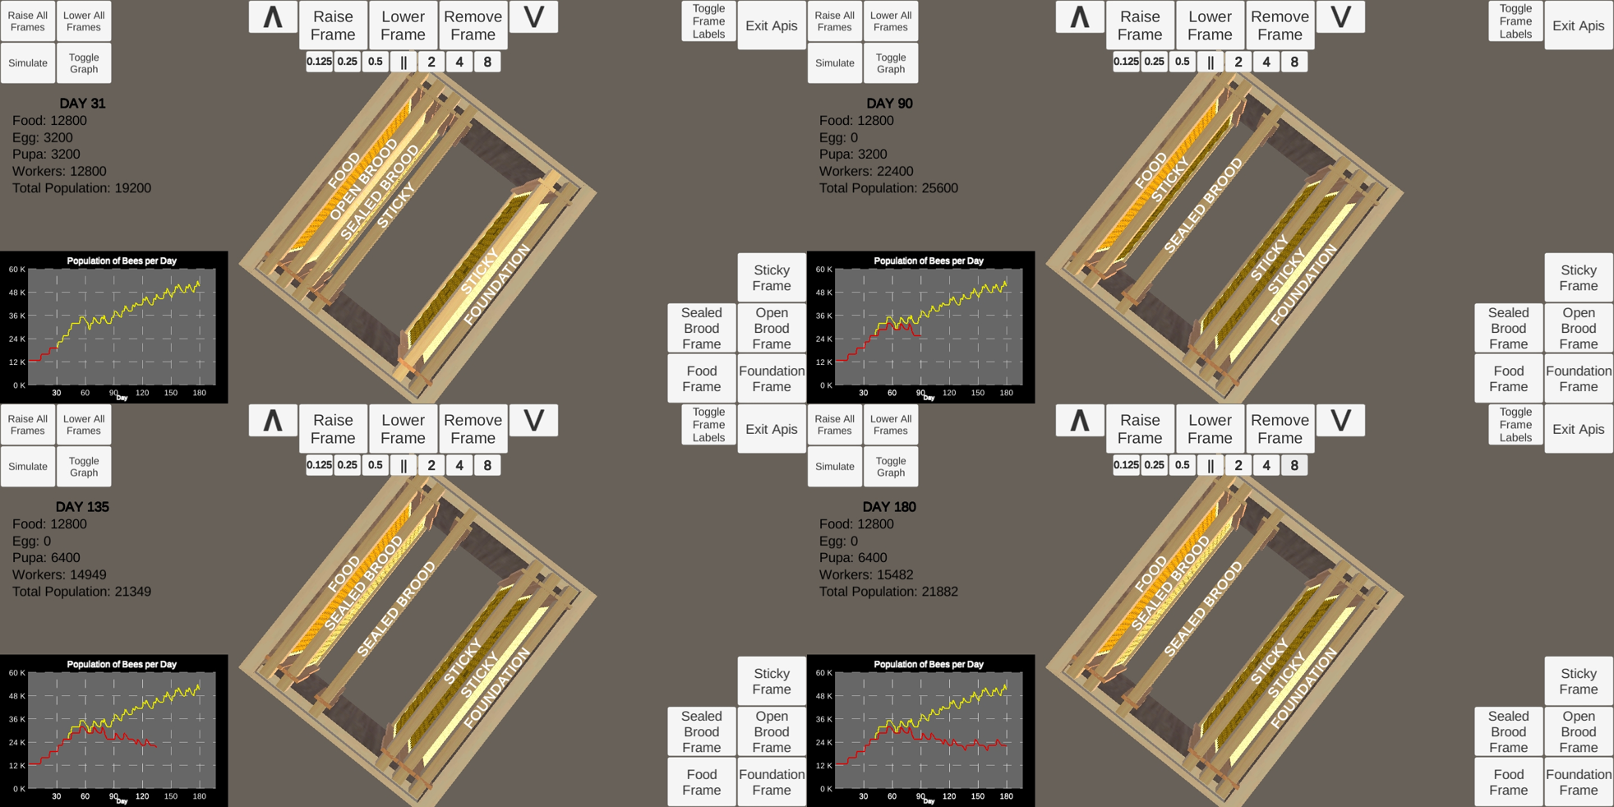

Figure 19: Image sequence depicting improper beehive management

# CONCLUSION

The researcher was able to create 3D models of the equipment used for beekeeping. The researcher was successful in developing a working mobile simulation application about proper seasonal beehive management. Multiple scenes were also developed to cater for different purposes of using the mobile simulation app, such as the Quiz, Automatic Beekeeping, and Manual Beekeeping.

# RECOMMENDATIONS

The mobile simulation application was able to simulate beehive management and show the outcomes of users interacting with the hive. The researcher recommends the following for the improvement of the mobile application:

• Improve the accuracy and precision of the simulation logic.

• Create more intricate textures for individual hive cells, such that it more accurately reflects the data of the cells in each frame.

• Improve the look-and-feel of the user interface such that interaction with the hive is made easier for general users.

• Include environmental conditions and bee diseases that can affect the collective growth and strength of the Langstroth beehive.

# REFERENCES

Agera, S.I.N. (2011). Role of beekeeping in the conservation of forests. *Global Journal of Agricultural Sciences, 10*(1), 27-32. Retrieved from https://www.ajol.info/index.php/gjass/article/viewFile/79068/69377

Bradbear, N. (2009). Bees and their role in forest livelihoods. *A Guide to the Services Provided by Bees and the Sustainable Harvesting, Processing and Marketing of Their Products*. Retrieved from http://www.fao.org/3/a-i0842e.pdf

Barbosa, H. (2015). 3D simulation environment: education and training. In *Proceedings of the 10th Doctoral Symposium in Informatics Engineering*, 132-133. Retrieved from https://www.researchgate.net/publication/319220185_3D_Simulation   
_Environment_Education_and_Training

Cervancia, C.R., Fajardo, A.C., Jr., Manila-Fajardo, A.C., & Lucero, R.M. (2012). Management of Philippine Bees: Stingless Bees and Honey Bees with Bibliography of Philippine Bees. Los Banos, Laguna: University of the Philippines Los Banos Bee Program

Clariño, M. D. (2013). *3D seasonal beehive management simulation* (undergraduate special problem). University of the Philippines Los BaÃ±os, Laguna, Philippines

Heier, C. (2015). Free to play: mobile gaming and the precipitous rise of freemium. In *The Review: A Journal of Undergraduate Student*, *16*(4), 1-2. Retrieved from http://fisherpub.sjfc.edu/ur/vol16/iss1/4

Intensive Beekeeping Training Seminar. (2015). Retrieved from https://www.pinoybeekeepersforum.com/2015/11/04/intensive-beekeeping-training/

Institute of Biological Sciences, UPLB. (2013). *UPLB Bee Program* [PDF file] (para. 1). Retrieved from https://aboutphilippines.org/files/uplbbee.pdf

Nazir, N., Iqbal, M. A., Sarwar, A., Altaf, M. N. (2011). Modern simulation and modeling techniques used For virtual object animations. In *International Journal of Advanced Research in Computer Science*, *2*(2), 66. Retrieved from http://www.ijarcs.info/index.php/Ijarcs/article/download/364/354

Santosa, H., Ikaruga, S., Kobayashi, T. (2016). 3D interactive simulation system (3DISS) using multimedia application authoring platform for landscape planning support system. In *CITIES 2015 International Conference, Intelligent Planning Towards Smart Cities*, Surabaya, Indonesia, 248. Retrieved from https://www.sciencedirect.com/science/article/pii/S1877042816307534

Serrano, K. J. V. (2011). *Computer simulation tool for the proper bee hive management training module* (undergraduate special problem). University of the Philippines Los BaÃ±os, Laguna, Philippines.

Sugimura, R., Kawazu, S., Tamari, H., Watanabe, K., Nishimura, Y.,Oguma, T., Inoue, H. (2014). Mobile game for learning bacteriology. In *10th International Conference Mobile Learning*, 285. Retrieved from https://files.eric.ed.gov/fulltext/ED557221.pdf.

UPLB Bee Program. (2014). Retrieved from https://idsc.uplb.edu.ph/agriculture-cluster/bee-program